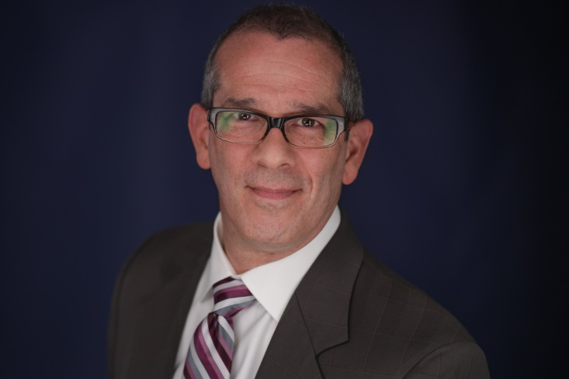

ABOUT DR. SHARIFI

Having earned a certificate in prosthodontics, Dr. Sharifi is a refined general dentist with advanced training in the restorative aspects of dentistry. He received his DDS degree from the University of Illinois at Chicago, then continued his education to earn a certificate in prosthodontics from Northwestern University Dental School. Dr. Sharifi also earned a master’s degree in dental biomaterials from Northwestern University.
Dr. Sharifi is a nationally recognized dental instructor on the topics of dental implants, full and partial dentures, overall patient care, and restoring root canal-treated teeth. He travels every other Friday to study clubs, associations and dental meetings where has presented several hundred lectures internationally and nationally, reaching nearly every state. Dr. Sharifi was named to the select American Dental Association (ADA) National Speakers Bureau in 1996. In 2007, he received the coveted Gordon J. Christensen Lecturer Recognition Award for excellence in teaching and loyalty to the profession.
Dr. Sharifi has been honored with membership in the American Academy of Restorative Dentistry and American College of Dentists. He is active in the Chicago Dental Society, the Illinois State Dental Society, and the ADA – where he served for more than a decade on the Council on Dental Practice. Dr. Sharifi also is a member of the American College of Prosthodontics, for which he has chaired the Committee on Dental Insurance and Managed Care. For more than ten years, he has participated as a member in the Northern Illinois Dental Specialty Study Club and recently joined as a charter member of the Seattle Study Club of Oak Brook.
Outside of the office, Dr. Sharifi spends the majority of his time with his family. He has three amazing daughters whose exploits on stage keep him busy and proud. He loves to read novels and will ask about what you’re reading when you arrive with a book in hand. Dr. Sharifi enjoys hiking, skiing and – because he has only daughters, was raised with only sisters and works in a dental office with only women – likes to attend car shows and photograph the beautiful restorations to spend time with some of the guys.

