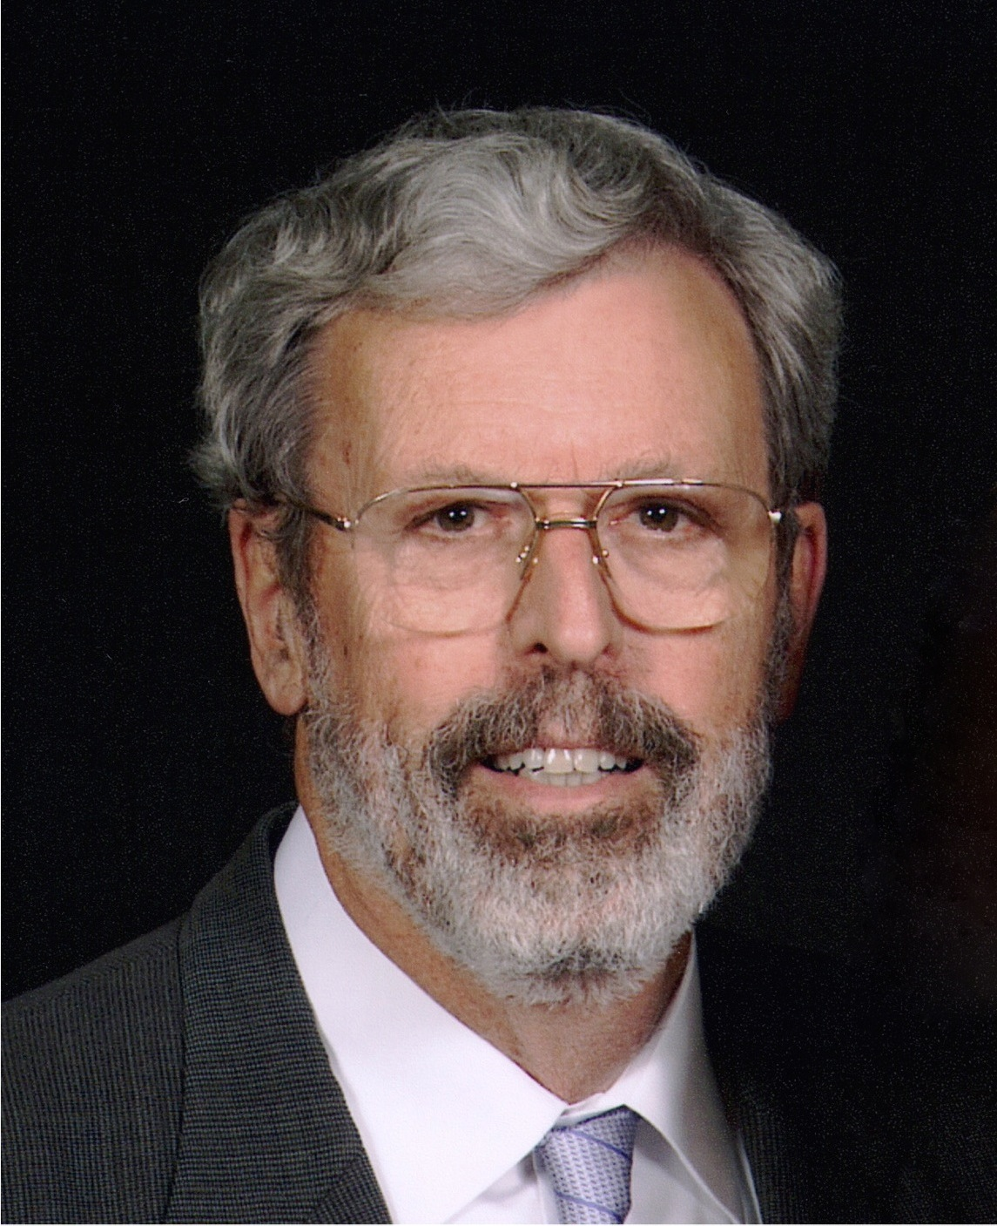

Raymond L. Bertolotti received his D.D.S. degree from the University of California, San Francisco, after working as a Ph.D. metallurgical and ceramic engineer at Sandia National Laboratories. Dr. Bertolotti is perhaps best known for introducing “total etch” to North America in 1984. He also introduced Panavia in 1985, tin plating in 1989, self-etching primers in 1992, HealOzone in 2004 and zirconia adhesion bridges in 2017. As a founder of Danville Materials and former Director of Research, the sectional Contact Matrix system, "MicroPrime", "MicroEtcher" sandblasting and intraoral tin-plating are also his developments. In addition to authoring four dental textbook chapters and co-authoring a recent textbook, Dr. Bertolotti has published extensively in journals such as the American Dental Association, International Journal of Prosthodontics, Dental Clinics of North America, Journal of Dental Research and Quintessence International. In 2013, he received the Lifetime Achievement Award from Academy of Biomimetic Dentistry. Dr. Bertolotti is also a Fellow of the Academy of Dental Materials, a Fellow of the International College of Dentists, Fellow of the Pierre Fouchard Academy, and is Accredited by the American Academy of Cosmetic Dentistry. He has served on the Reality Editorial team. He is a well known international lecturer, having presented at all of the major dental meetings such as the ADA, Hinman, Chicago Midwinter, British Dental Meeting and invited lectures in over 30 countries.

"New Concepts for Better Clinical Dentistry which is actually fun to provide”
Presented by Raymond Bertolotti, DDS, PhD
Dr. Bertolotti will cover the following topics and a few more:
Bulkfill composite – polymerization shrinkage is the enemy
· Understand the clinical consequences of polymerization shrinkage
· Easily create margins free of white lines (enamel fracture) and later staining
· Observe polymerization shrinkage in real time with revolutionary OCT
· Why “low shrinkage composites” do not help and likely are worse
· Stop creating open gingival margins and the associated “recurrent caries”
Zirconia – choose the materials and applications carefully
· Why only Y3 zirconia (3 mol percent yttria) does not fracture
· The porcelain brand which works best on zirconia frames and why so
· Revolutionary zirconia adhesion bridges (almost no prep)
· The best alternative to most anterior implants
· Why E.max is usually superior to posterior zirconia
Adhesion – utilized to the maximum on all dental surfaces
· Intraorally bond gold to gold (no, it’s not welding!)
· Stay supragingival and get outstanding esthetics with ceramic
· Best possible bond strengths to dental surfaces compared to enamel.
· Bond porcelain well without HF etching (20 plus year recalls prove it)
· Why you should retire if you don’t have a Microetcher
Some Fun Dentistry – low stress and highly profitable too
· Reattach fractured off incisor fragments (even with bleeding pulps)
· Why veneers, not crowns, are often the preferred anterior restoration
· Try-in veneers for esthetics without “Try-in pastes” which require removal
· Easily make implant access holes disappear
· Anterior “white spots” easily removed

